  - The annual James H. Walker / Turner School of Construction Management program started in Cleveland in 1969 by Turner Construction Company and the City of Cleveland with the mission to support small business growth within the local community. The program offers a series of practical courses led by instructors who have years of construction industry knowledge and expertise. Today, with the partnership of Cuyahoga County Community College, the program is held at Tri-C’s Metro Campus.
Approaching its 47th year, the program has graduated more than 2,200 participants, helping more than 500 companies obtain contracts directly with the City of Cleveland!
With 40+ students currently enrolled in this year’s program, Turner and the City of Cleveland are positioned for another year of success in helping local S/M/W/DBE certified businesses to enhance technical, administrative and managerial skills necessary to do business in the construction industry.
While the 2017 session is currently at capacity, applications for the 2018 session are now being accepted. (see back for registration info.)
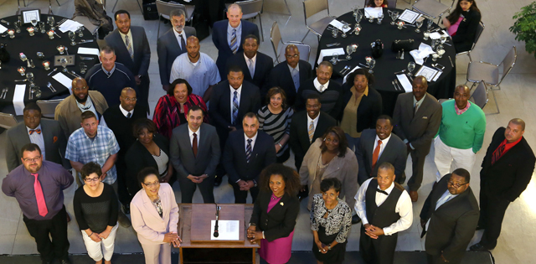
James H. Walker/Turner School of Construction Management graduating class of 2016.

FAQs:

Who can enroll?
The program is a free program available to owners and employees of small businesses; including minority-, women-, and disabled-business enterprises.
What are the course offerings?
Course topics include areas such as setting up a business, management, accounting basics, insurance and bonding, marketing, contract risk management, how to conduct business and certification programs with the City of Cleveland.
Program dates:
The program commences on Wednesday, February 22, 2016, from 6:00-8:30pm. Courses are held every Wednesday, from 6:00-9:00pm, thereafter for 11 weeks. The 12-week program concludes with a graduation ceremony at Rotunda Hall at City Hall.
Where are classes held?
Classes are held at Tri-C’s Metro Campus Unified Technologies Center (UTC) in Cleveland.
What are the program’s benefits?
The program improves economic viability and increases opportunities for the utilization of MWDBEs in Northeast Ohio. Graduates receive practical knowledge of navigating through the construction industry and the opportunity to connect directly with Turner’s network of professionals, subcontractors and vendors.
  - JAMES H. WALKER / TURNER SCHOOL OF
CONSTRUCTION
MANAGEMENT

SIGN UP!
Turner’s VP and General Manager, Jason Jones, looks on as City of Cleveland’s Chief of Public Affairs, Natoya Walker Minor, commends the 46th graduating class of the James H. Walker/Turner School of Construction Management program.
Contact Us
TURNER CONSTRUCTION CO.
1422 Euclid Avenue, Suite 200
Cleveland, Ohio
(216) 522-1180
www.turnerconstruction.com

To sign up for next year’s session, please contact Marcus Henry at mhenry@tcco.com and include “2018 TSCM” in the subject line.
TURNER CONSTRUCTION CO.
1422 Euclid Avenue, Suite 200
Cleveland, Ohio

