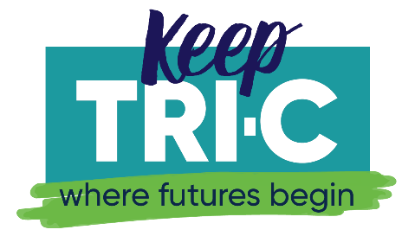

Just the Facts

FACT: After 50 years of wear and tear, technological change, and shifts in the job market, Tri-C's facilities need to be repaired, improved, and expanded.
FACT: Tri-C is asking voters to support a bond issue that will cost less than $1.50 a month ($100,000 home valuation).
FACT: The College will use the bond issue funds to:
- Update labs, equipment, and technology for workforce training and health care and other technical education programs that prepare students for good jobs, right here.
- Expand classrooms, labs, and equipment for advanced technology training programs like science, math, manufacturing, engineering, robotics, energy, public safety, security, and computers.
- Make essential building repairs to electrical, plumbing, security, technology and HVAC systems, and to provide access for people with disabilities. Every campus will be improved.
FACT: In the last decade, when tight state budgets significantly cut funding for colleges, Tri-C worked hard to keep up its campuses, but to meet these needs, a bond issue is critical to provide the resources.
FACT: 85% of Tri-C graduates continue to live and work in Northeast Ohio and contribute to the economic growth of the region.
FACT: For every $1 invested in Tri-C, the College provides a return of $10.50 in economic benefit to the community.
FACT: Tri-C is Ohio’s first and largest community college and serves 55,000 credit and non-credit students annually.
FACT: Tri-C is the region’s leading provider of education for our area’s technical workforce, health care professionals, and students preparing to enter four-year degree programs.
FACT: More than 900,000 Cuyahoga County residents have come through Tri-C’s doors to improve their lives.
FACT: The bond issue will protect the public’s investment in a vital community asset.
FACT: Early voting begins on October 11. Election Day is November 7.

